MORNING WORSHIP SERVICE
November 9, 2014

Opening Song “He Has Made Me Glad”

Opening Prayer

Worship Hymns “Spirit of the Living God” 244
“Praise Him! Praise Him!” 227
“How Great Thou Art” 10
“Here I Am to Worship”
“Open Our Eyes”

Offering/Offertory

Special Music

Message Bro. Kenny McCoy

Invitation “Pass Me Not, O Gentle Savior” 308

Announcements

Closing Prayer

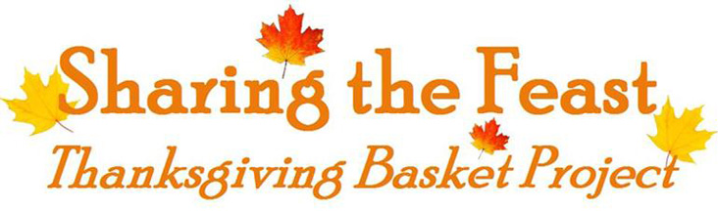

NURSERY – available for children age 0 to Kindergarten
Patti Radford, Garlyn Radford

Hostesses for November Ushers for November
Ruth Rucker, Evelyn Robinson, Wesley McManus, Wesley Seigmund
For information contact Evelyn Robinson
512-294-6770

Pam Daniel, Mickey Stanford Jimmy Miller, Joe Daniel

Prayer & Request Information

(Please complete name & address information on reverse side)

I would like to speak with the Pastor.

I would like more information on this church.

I have Prayer Requests or Needs

Date:

Permission to Publicize:
Church Bulletin Yes No
Email Prayer Chain Yes No

Prayer Request:

Prayer For
Name
Address
Phone

Given By
Name
Address
Phone
Please Contact By

Card Phone Visit

Comments

Immediate Need Prayer List

Pray for Lonnie & Glenda McCoy as Lonnie continues to fight cancer

Pray for Maxine Morris (Diann Stutes’ sister) as she begins chemo treatments for abdominal cancer

Pray for Jeff Bunting (friend of Connie Kahlstrom) as he deals with a severely injured shoulder that may need surgery

Pray for those among us with unspoken prayer requests

K s b c

Keeping His Word through Sunday School, Bible Study and Church Attendance/Worship

Sunday School Bible Studies for November:

Nov. 2nd Overcoming Being Forgotten Gen. 39:21-23; 40:5-8, 20-23 Nov. 9th Overcoming Hard Times Gen. 41:28-36, 46-49
Nov. 16th Overcoming Bitterness Gen. 45:3-11
Nov. 23rd Overcoming an Earthly Mindset Gen. 50:15-21
Nov. 30th Ministry in the Face of Mental Illness 2 Cor. 1:2-7

9:45 a.m. each Sunday – A place for everyone

WE’D LOVE FOR YOU TO JOIN US!

